# Lab: HTML and CSS Overview

Problems for exercises and homework for the ["Web Fundamentals – HTML5" course @ SoftUni](https://softuni.bg/courses/web-fundamentals-html5).

Submit your solutions in the SoftUni judge system at <https://judge.softuni.bg/Contests/391/Lab-HTML-and-CSS-Overview> .

## Welcome to HTML

Create a Web Page like the following.

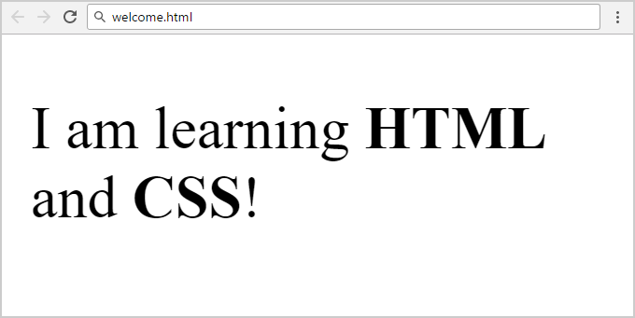

Create "**welcome.html**"

### Constraints

* Change the title
* Use paragraph tag for text and strong tag for bold text

## Fruits

Create a Web Page like the following.

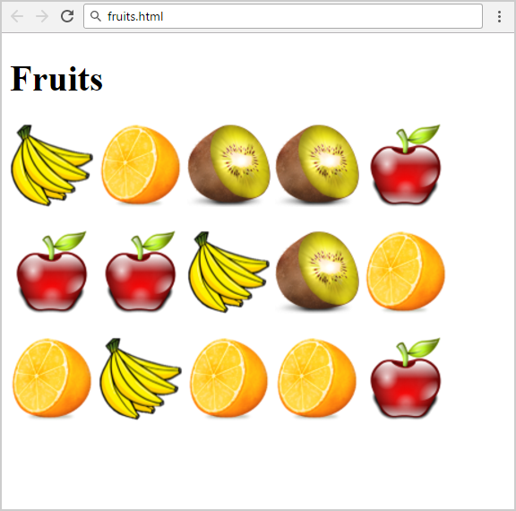

Create "**fruits.html**"

### Constraints

* Titile: Fruits
* <h1> tag for **heading**
* <img> tag for images

### Hints

Use:

* Use 3 **paragraphs**, each holding 5 images

## Wiki Page

Create a Web Page like the following.

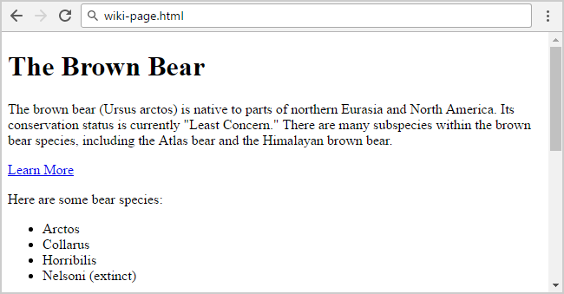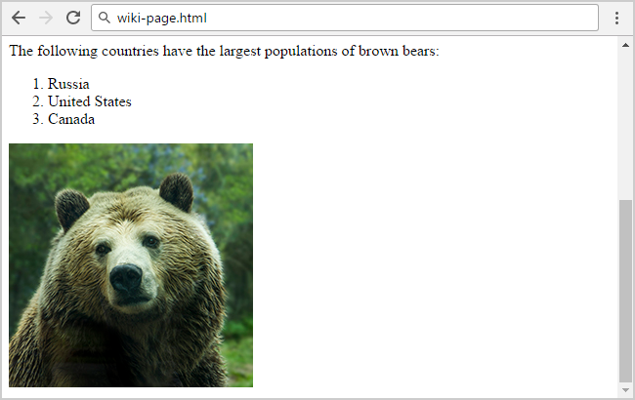

Create file: "**wiki-page**"

### Constraints

* Title: **The Brown Bear**
  + <h1> for heading
* Hyperlink: <https://en.wikipedia.org/wiki/Brown_bear>
* Text: **use paragraph**
* List: **use ordered list and unordered list**
* Image: **bear.jpg**

## To Do List

Create a Web Page like the following

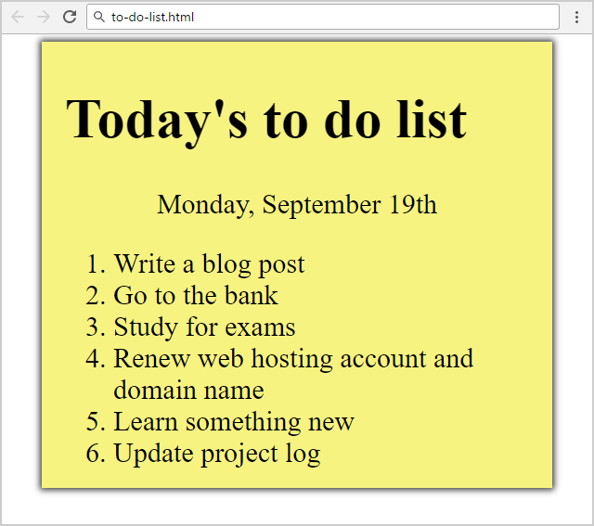

Create two files: "**to-do-list.html**" and "**to-do-list.css**"

### Constraints

* **<div>** with **class="my-list"** as container
  + Background color: **#f7f381;**
  + Padding: 8px 24px;
  + Width: 500px;
  + Text size: 30px;
  + Border: 1px solid #f7f381;
  + Background Color: #f7f381;
  + box-shadow: 0 0 10px 2px #333333;
* <ol>
  + Margin: 12px;
* <p>
  + Center the text

### Hints

* Center the **container**
* Heading: use <h1>
* Date: use <p> + center it
* List: use <ol>

## HTML Lists

Create a Web Page like the following

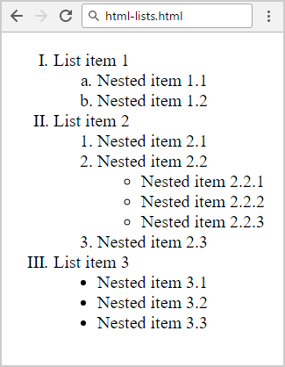

Create file: "**html-lists.html**"

### Hints

Use: <ol>, <ul> and <li> and <span> for List Item 1, List item 2 and List Item 3